**AIM**

To implement a guessing game.

**DESCRIPTION**

Here implementing guessing number game using Verilog. A player has to select the number from 0 to 7 in which only one number is correct if the player select the wrong number then a warning sign will be generated which helps the player to guess the right number In this manner, the Guessing number game will work till the player reaches the desired number.

* The project includes 4 parts
* Providing eight 3-bit inputs (number to be guessed by the player )

Comparing every guess against that desired number.

* Giving appropriate feedback to the player based on whether the guess is smaller or larger than the original number or desired number.
* Displaying “You Won” for correctly guessing the number

**DESIGN**

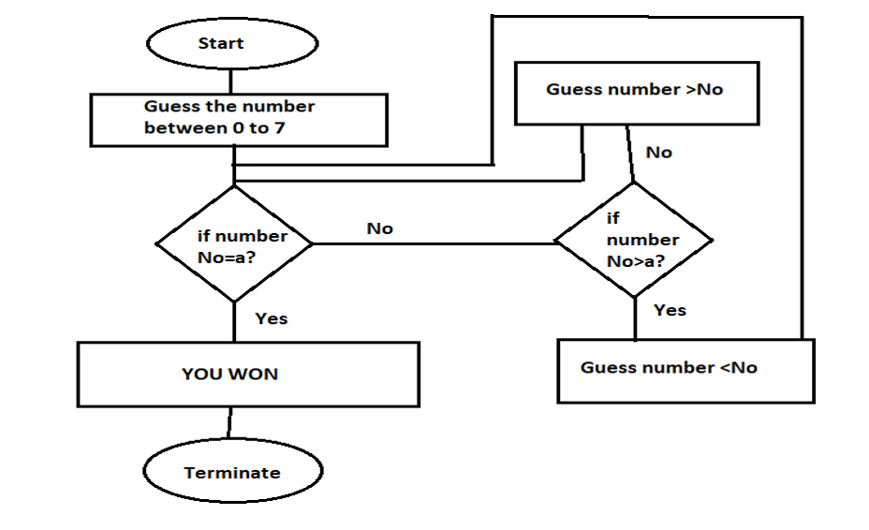

**VERILOG CODE**

module gussing_game( Out,Sel,No1,No2,No3,No4,No5,No6,No7,No8);

input [7:0] No1,No2,No3,No4,No5,No6,No7,No8;

input [2:0] Sel; //The three bit selection line

output [7:0] Out;

reg [7:0] Out;

//Check the state of the input lines

always @ (*)

begin

case (Sel)

3'b000 : Out = No1;

3'b001 : Out = No2;

3'b010 : Out = No3;

3'b011 : Out = No4;

3'b100 : Out = No5;

3'b101 : Out = No6;

3'b110 : Out = No7;

3'b111 : Out = No8;

default : Out = 8'bx;

//If input is undefined then output is undefined

endcase

end

endmodule

**TESTBENCH**

module gussinggame_tb;

// Inputs

reg [2:0] Sel;

reg [7:0] No1,No2,No3,No4,No5,No6,No7,No8;

// Outputs

wire [7:0] Out;

gussing_game uut (Out,Sel,No1,No2,No3,No4,No5,No6,No7,No8);

initial begin

Sel=3'b000;No1=0;No2=0;No3=0;No4=1;No5=0;No6=0;No7=0;No8=0;

#1 $display("Wrong, Guess no greater than 0");

#10 Sel=3'b001;No1=0;No2=0;No3=0;No4=1;No5=0;No6=0;No7=0;No8=0;

#1 $display("Wrong ,Guess no greater than 1");

#10Sel=3'b010;No1=0;No2=0;No3=0;No4=1;No5=0;No6=0;No7=0;No8=0;

#1 $display("Wrong ,Guess no greater than 2");

#10 Sel=3'b011;No1=0;No2=0;No3=0;No4=1;No5=0;No6=0;No7=0;No8=0;

#1 $display("You Won");

#10 Sel=3'b100;No1=0;No2=0;No3=0;No4=1;No5=0;No6=0;No7=0;No8=0;

#1 $display("Wrong, Guess no less than 4");

#10 Sel=3'b101;No1=0;No2=0;No3=0;No4=1;No5=0;No6=0;No7=0;No8=0;

#1 $display("Wrong ,Guess no less than 5");

#10 Sel=3'b110;No1=0;No2=0;No3=0;No4=1;No5=0;No6=0;No7=0;No8=0;

#1 $display("Wrong ,Guess no less than 6");

#10 Sel=3'b111;No1=0;No2=0;No3=0;No4=1;No5=0;No6=0;No7=0;No8=0;

#1 $display("Wrong, Guess no less than 7");

#10$finish();

end

initial

begin

$monitor($time,Sel,No1,No2,No3,No4,No5,No6,No7,No8,Out);

$dumpfile("dump.vcd");

$dumpvars;

end

endmodule

**SIMULATION RESULTS**

